Part 1- Literary terms

Part 2- Passage questions (see practice test)

Part 3-MLA Format, titles, and essay structure

Literary terms- Review the following literary terms and their definitions.

tone- Implied attitude of the writer towards the subject

mood- The way a text makes the reader feel.

simile- A comparison between two things using “like” or “as”
Ex: “You’re as cuddly as a cactus, you’re as slimy as an eel, Mr. Gri---inch!”

metaphor-A direct comparison between two unlike things, stating that one is the other or does the action of the other.
Ex: Love is a fire.

personification Giving inanimate objects or abstract concepts living and animate qualities
Ex: The days crept by slowly

Imagery/sensory detail- Descriptive detail that helps the reader imagine the world of the piece and can also ad symbolism; draws on the five senses (sight, taste, hearing, smell, touch)

symbol- Any image or thing that stands for something else; often something visible that stand for something invisible.
Ex: lion as a symbol of courage

allusion- A brief reference to a well known person, historical event, work of art, or Biblical or mythological situation or character.
Ex: Uncle Sam, Romeo

hyperbole- An outrageous exaggeration used for effect
Ex: He weighs a ton.

Irony- A contradictory statement or situation to reveal a reality different from what appears to be true.

theme- A universal message that is communicated through a work of literature
Ex: Love endures all trials.

motif- An idea, image, or symbol that recurs (comes back, reappears) throughout a text to help to illustrate a central theme

juxtaposition- Two or more contrasting ideas placed close to one another in order to draw comparisons
Ex: light & dark, good & evil

foreshadowing- hints about what will happen later in a text

figurative language- A poetic or artistic language that is not literally true, such as symbolism, hyperbole, metaphor, personification

direct characterization- A description of appearance and explanation of character traits and attributes

indirect characterization- Showing who the character is without explicit description of their appearance or traits; using action and dialogue to show personality.

Third person-omniscient point of view (POV)- Told using pronouns like “he”, “she”, “it”, or “they”; narrator knows everything or almost everything.

Third person-limited POV- Told using pronouns like “he”, “she”, “it”, or “they”; narrator knows the thoughts and feelings of just one character.

First person limited POV- Told from the perspective of one of the characters in the story using “I”, “me”, “us”, “we” pronouns; usually the narrator only knows their own thoughts and feelings.

MLA Format

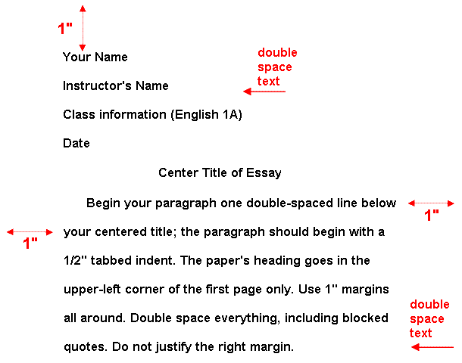

Heading

- See above. Note that the date should follow this format: 24 July 2018

Spacing

- Should be double-spaced throughout.

- Do not add extra spaces between paragraphs--that is a business format. Instead, make sure to continue indenting paragraphs one-half inch (the usual tab default setting).

In-text Citations

- The citation is placed at the end of the quote. The period goes AFTER the citation, not at the end of the sentence.

Children cry most when told they have to take a nap” (Allen 15)

- If only using one source, you only need to include the author’s name in the first in-text citation of the essay. Afterwards, your citations will look like this:

“Children cry most when told they have to take a nap” (15).

Formatting titles

Use italics or underlining when referencing titles of larger works such as the following:

- Books
- Music albums
- Movies
- Newspapers

Use quotes when referencing titles shorter works or works that are small parts of a larger whole:

- Songs
- Short stories
- Poems
- Newspaper articles

Essay Structure

