Source #7: Michigan Radio article: “How do we help Native American youth plagued by suicide, poverty?”
By Paulette Parker, March 16, 2016
Directions: As we read this text, annotate, add comments, ask questions, take note of interesting statistics, make connections to The Absolutely True Diary of a Part-Time Indian. Keep in mind our statement of inquiry: Access to equal opportunities can be complicated by personal, historical, and cultural points of view.

Less than two percent of the U.S. population identifies as Native American or Alaska Native.

Despite their low numbers, the groups are plagued by high rates of suicide and unemployment. And Native American youth lag behind other ethnic groups in education attainment.

The U.S. Department of Education wants to better prepare these at-risk kids for college and beyond.

The Department is more than tripling – from $5.3 million to $17.4 million – the availability of funding for grants to help Native American youth become college- and career-ready.

Demonstration awards ranging from $500,000 to $1 million for tribal communities are expected before September 30.

The extra support is being provided for Native Youth Community Projects, and the grants will support President Obama's Generation Indigenous "Gen I" Initiative, to help Native American youth.

More dire than mascots and casinos
There are 567 tribes, including 229 Alaska Native communities, currently recognized by the federal government. Many face exploitation of natural resources, inadequate healthcare, and mass incarceration.
According to the Huffington Post:
...beyond the slot machines, the movie sets and the football fields, there are other problems facing Native communities -- insidious, systemic, life-or-death problems; the kinds of problems it takes years and votes and marches to resolve -- that aren't getting nearly as much attention.

A suicide epidemic
The Pine Ridge Reservation in South Dakota is home to the Oglala Sioux Tribe.

Between December 2014 and October 2015, 19 kids on the reservation ended their lives, including 12-year-old Santana Janis.

And many more tried, but failed.

Native American youth have the highest rate of suicide among all ethnic groups in the U.S., and it's the second-leading cause of death for Native youth ages 15-24.

That's two and a half times the national rate for the same age group.

According to The Washington Post:
A toxic collection of pathologies — poverty, unemployment, domestic violence, sexual assault, alcoholism and drug addiction — has seeped into the lives of young people among the nation’s 567 tribes. Reversing their crushing hopelessness, Indian experts say, is one of the biggest challenges for these communities.

Joblessness and poverty
Right now the unemployment rate in the U.S. is 4.9 percent, according to the Bureau of Labor and Statistics. For Native Americans, the unemployment rate is a staggering 22 percent, more than twice that of Hispanics and African-Americans. As a result, one-in-four Native Americans is currently living in poverty – about double the rate of the general population.

According to the Economic Policy Institute:
American Indians have endured very high levels of unemployment in the wake of the Great Recession. The American Indian unemployment situation is worse than average in the Midwest, Northern Plains, and Southwest regions.

Native American youth are falling behind in education
Today, Native youth post the worst achievement scores and the lowest graduation rates of any student subgroup.

According to U.S. News:
[In 2014] 67 percent of American Indian students graduated from high school compared to the national average of 80 percent. And many of their school facilities have been equally neglected, lacking even basic essentials such as heat and running water.
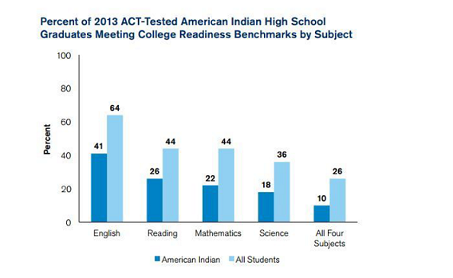
Many Native American students want to pursue an education past high school, but they just don't seem to be prepared.

Just 10 percent of Native American students met all four of the ACT's college readiness benchmarks in 2013.

And more than half didn't meet any of the benchmarks at all.

How do we fix what's broken?

So, here's where the $17.4 million from the U.S. Department of Education comes in.

Each grant will support a coordinated, focused approach chosen by a community partnership that includes a tribe, local schools and other optional service providers or organizations.

According to a press release:
The program allows tribes to identify ways to achieve college and career readiness specific to their own populations - which could include any number of approaches, such as early learning, language immersion or mental health services. Communities can tailor strategies to address barriers to success for students in college-and-career readiness. The success of these projects will guide the work of future practices that improve the educational opportunities and achievement of preschool, elementary and secondary Indian students.

John B. King is the acting U.S. Secretary of Education. He said in the release:
In too many places across Indian Country, Native youth do not receive adequate resources to help prepare them for success in school or after graduation. The Native Youth Community Projects are an investment in bringing tribal communities together to change that reality, and dramatically transform the opportunities for Native youth. When tribal communities join together around shared goals for Native youth, we will see locally driven solutions coming from leaders who work most closely with students and are best-positioned to lead change.

Partner + Evidence activity:
Consider the items from the article that we just read:
•Education
•Joblessness
•Poverty

With a partner, brainstorm 4-5 places in the text that demonstrate any of these three items above for any characters in the text (your partner group should aim to move past things that we’ve already talked about). Write the character, quote, and page number onto separate sticky notes (see example):

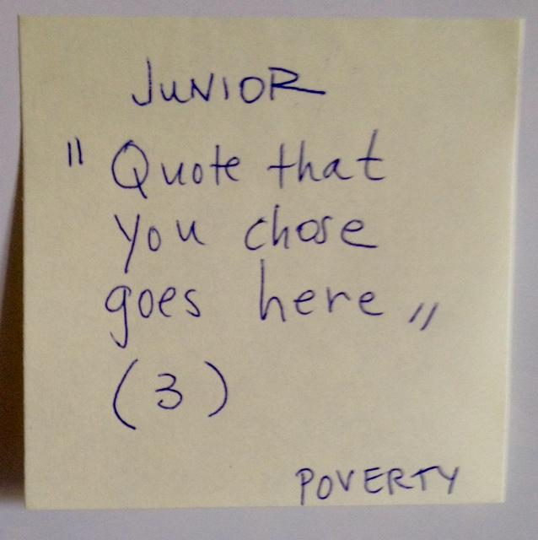

We will come back together as a class to share what we noticed in the text so far.
1. Place your sticky notes into the appropriate categories on the back board.

2. Put similar characters together and add the character’s name in marker.

3. Be ready to talk and share your moments/quotes (you don’t need to remember them word for word).

