MAUS II: Keeping it All Together
Chapter Notes (Participation with Random Formative Selection)
For each chapter of Maus you complete, you must submit annotations showing your understanding of the plot, as well as details that you note for one panel, which will be provided.

If you are presenting your IOC on a panel that is in that chapter, you do not need to submit annotations for that one chapter. (For example, if you are presenting on a panel from Chapter 2, then you only need to submit the annotation sheets for Chapters 1, 3, 4, and 5.)

Individual Oral Commentary (Summative)
Your IOC will be a major grade this unit. It will be worth double your test, so you need to prepare well in advance.

MAUS II Test (Summative)
The test, which will be at the end of the unit, will be a summative grade.

Here’s a Checklist to Help You Keep It All Together:
☐ “Living in Line” Guide
☐ Chapter One Notes and Annotations
☐ Chapter Two Notes and Annotations
☐ Chapter Three Notes and Annotations
☐ Chapter Four Notes and Annotations
☐ Chapter Five Notes and Annotations
☐ Individual Oral Commentary (IOC) Outline
☐ Individual Oral Commentary (IOC)

Chapter One Notes and Annotations
New Terms and Definitions from this Chapter | Character Development
Plot Development | Questions About This Chapter
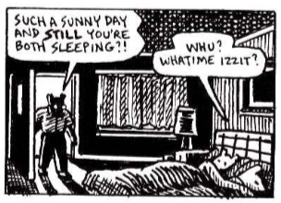

Chapter Two Notes and Annotations
New Terms, Words, and Definitions from this Chapter | Character Development
Plot Development | Questions About This Chapter
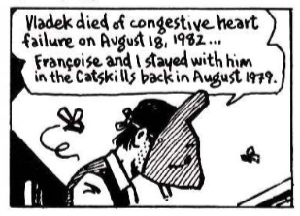

Chapter Three Notes and Annotations
New Terms, Words, and Definitions from this Chapter | Character Development
Plot Development | Questions About This Chapter

Chapter Four Notes and Annotations
New Terms, Words, and Definitions from this Chapter | Character Development
Plot Development | Questions About This Chapter

Chapter Five Notes and Annotations
New Terms, Words, and Definitions from this Chapter | Character Development
Plot Development | Questions About This Chapter
